1+2)
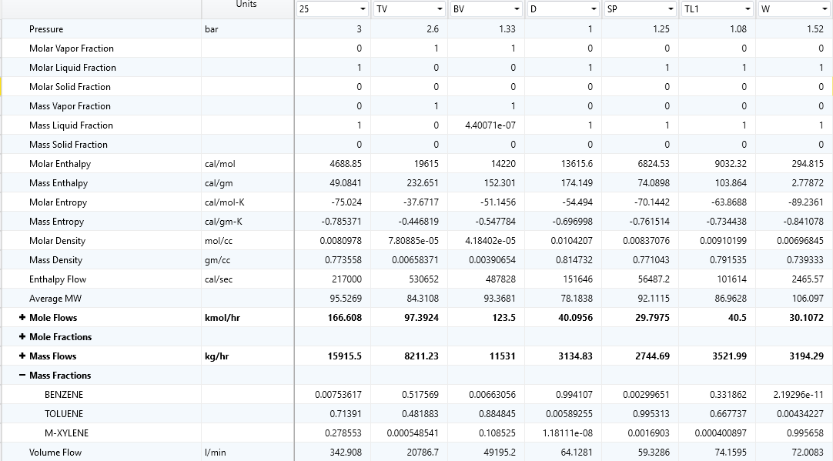
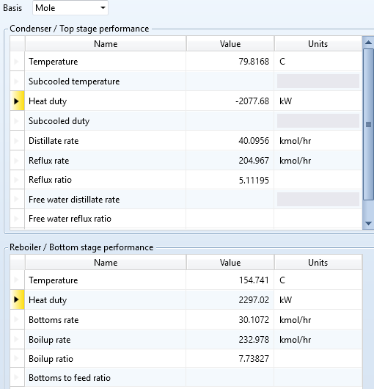
SIDE STREAM STAGE: 26
VAPOR SIDE STREAM: 123.5 kmol/hr
LIQUID SIDE STREAM: 40.5 kmol/hr
Total number of plates: 53
Streams for the main petlyuk column(2)
Incoming liquid stream:8
Outgoing liquid stream:9
Incoming vapor stream: 35
Outgoing vapor stream: 34
For first column(1)
Feed stage: 20
Distillate rate:40 kmol/hr
Reboiler duty:2800 kW
3)From this lab we have reboiler duty of column is:
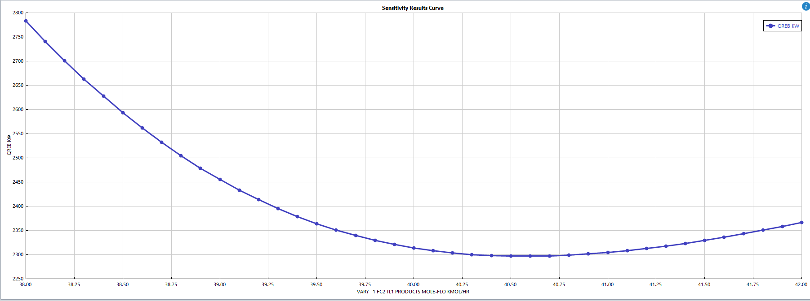
Column reboiler duty: 2297.02 kW
For previous lab we had direct split more economical heat cost wise.
Column reboiler duty: 2312.5 kW
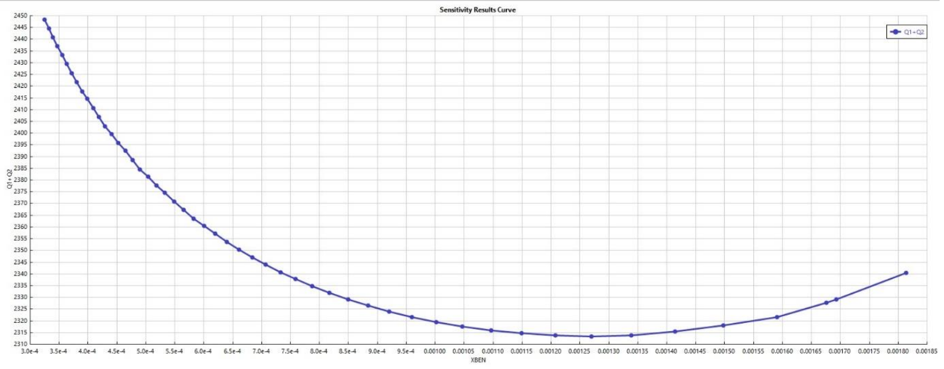
From energy efficiency perspective petyulk column is better than normal columns(direct split)
NAME: SHRIMI AGRAWAL ROLL NUMBER:221036

